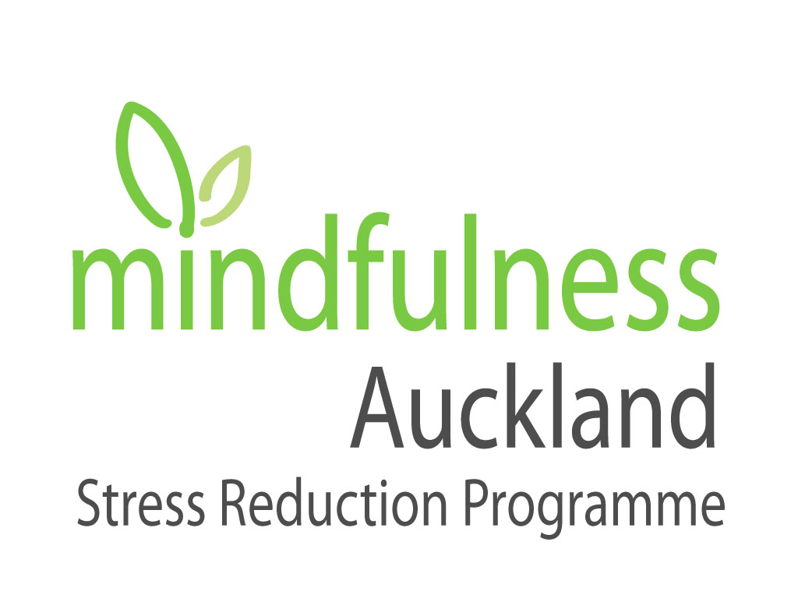

Registration Form

6 Week Self-Compassion Graduate Courses

Date of the Course:

Time: Evenings: 7.00 – 9.00pm

____________________________________________________________________________

Thank you for filling out these forms. We realize the personal nature of these questions.
Please be assured that the completed forms are kept in strict confidence.

Name: ………………………………………………………………………………………………….……

Address: ……………………………………………………………………………………...................…

Phone Number: …………………………………… Occupation: …………………….……………..

Email address: ……………………………………………………………………………………….…….

Date of Birth: …………………………………........ Next of Kin: ……………….…………………..

Phone Number: ………………………………

When did you complete the MBSR 8 week course (approximately) ?

…………………………………………………………………………………………………………..…..

Please describe your reasons for enrolling in the Self Compassion course:

…………………………………………………………………………………………………………..…..

…………………………………………………………………………………………………………….…

…………………………………………………………………………………………………………..…..

…………………………………………………………………………………………………………….…

……………………………………………………………………………………………………….………

List three intentions you have for yourself in attending this course:

…………………………………………………………………………………………………………..…..

…………………………………………………………………………………………………………….…

……………………………………………………………………………………………………….………

…………………………………………………………………………………………………………….…

……………………………………………………………………………………………………….………

What, if any Mindfulness practices are you engaging in on a regular basis?

…………………………………………………………………………………………………………..…..

…………………………………………………………………………………………………………….…

……………………………………………………………………………………………………….………

Have you experienced any recent major stressors, e.g. new job, separations, bereavement etc?

…………………………………………………………………………………………………………..…..

…………………………………………………………………………………………………………….…

……………………………………………………………………………………………………….………

Are you currently on any prescribed medication?

…………………………………………………………………………………………………………..…..

…………………………………………………………………………………………………………….…
Is there anything that may limit your participation in this programme or need special attention?

…………………………………………………………………………………………………………..…..

…………………………………………………………………………………………………………….…

……………………………………………………………………………………………………….………

Any comments:

…………………………………………………………………………………………………………..…..

…………………………………………………………………………………………………………….…

……………………………………………………………………………………………………….………

(Changes from original)

Please email this registration form to:
Jenny at admin@mindfulnessauckland.co.nz

or send to:

Mindfulness Auckland
P.O. Box 78296 Grey Lynn, Auckland 1245

Payment of the fee of $400.00 plus GST can be paid directly into our bank account:
Please reference your invoice number
Westpac Bank Account: 03 0255 0751391 000

(Payment of the full fee is required before commencement of the course)

